34.77: a) 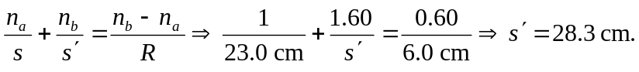
So the second object distance is
Also: 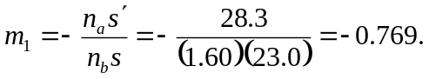
b) The object is virtual.
c) 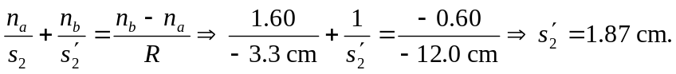
Also:
d) So the final image is real and inverted.
e)

